Ensuring master is clean

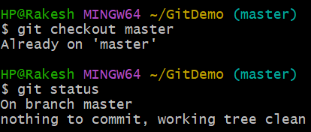

Creating a branch GitWork and adding file

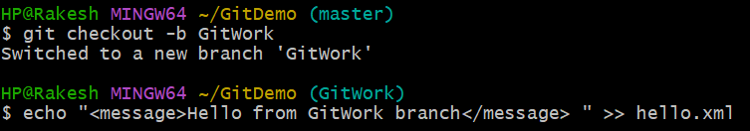

Check Status

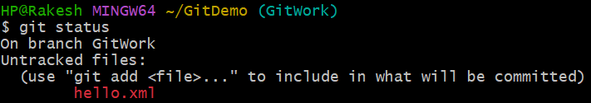

Committing Changes

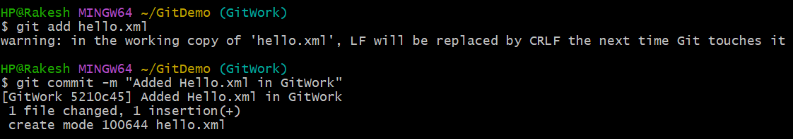

Switching to Master

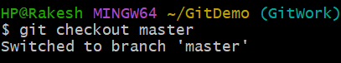

Adding a different version of hello.xml



Committing this version

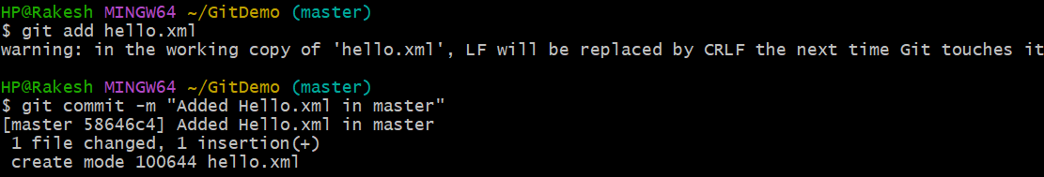

Visualizing commit history

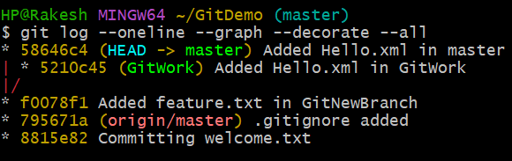

Checking CLI Differences

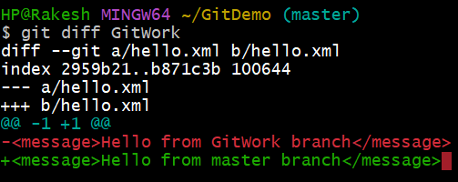

Using P4Merge for visual differences

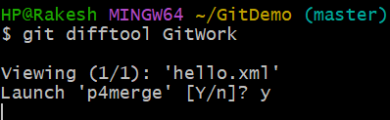

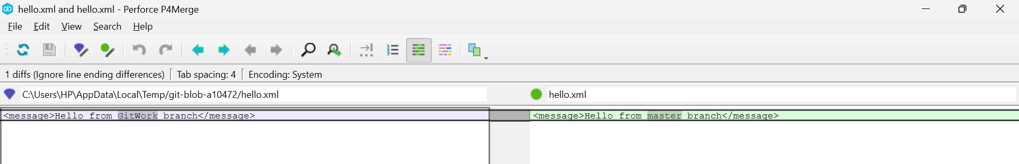

Attempting to merge GitWork into master

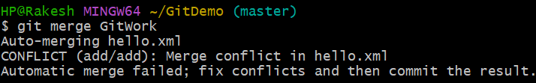

Observing Git markup

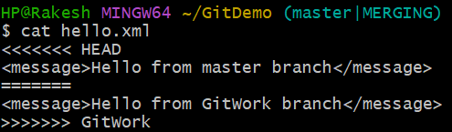

Using 3-way merge tool to resolve conflict

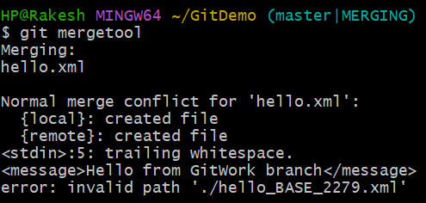

Committing the resolved file

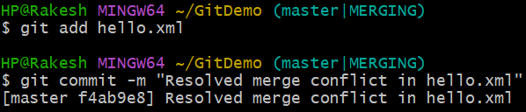

Checking status & adding backup file to .gitignore

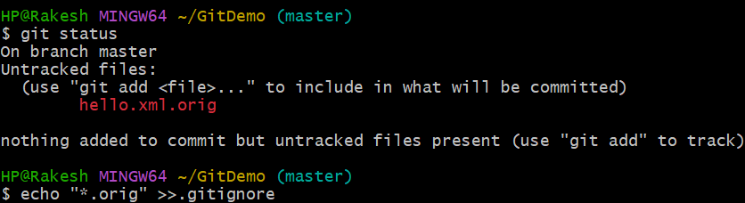

Committing the updated .gitignore

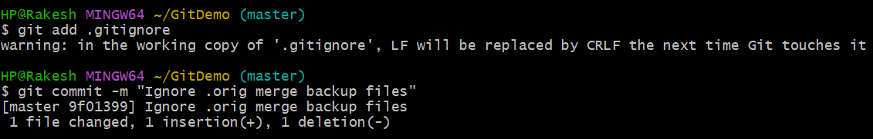

Listing all branches

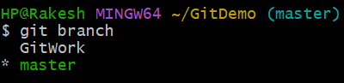

Deleting the merged branch

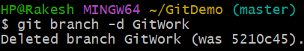

Final Log Observation

